All Instructions in Yellow Highlights
Website Sections in Order:
- First Hero section with pictures and Tagline – Refer instruction below
- Products ( 3 product cards with clickable POP-UP details)
- Sunnik Certifications (Add logos – Refer instructions below)
- Sunnik Exceptional track-record (Add images of the projects and clicking image should give POP-UP detail as given under each project)
- About Us
- Sunnik Our manufacturing partner
- Get In Touch (Contact Us)

Searchable Clickable line that appears on Google search:
Aspire Solutions – Authorised Distributor for Sunnik Tanks in Saudi Arabia | Premium GRP, HDG and SS Tanks

Home Page:
Hero section: 2 Image carousel with contact button and taglines as given below

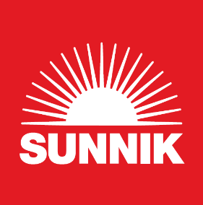
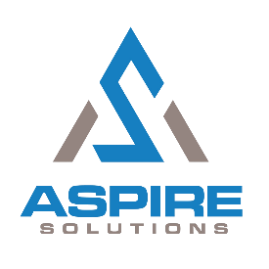

Photo 1
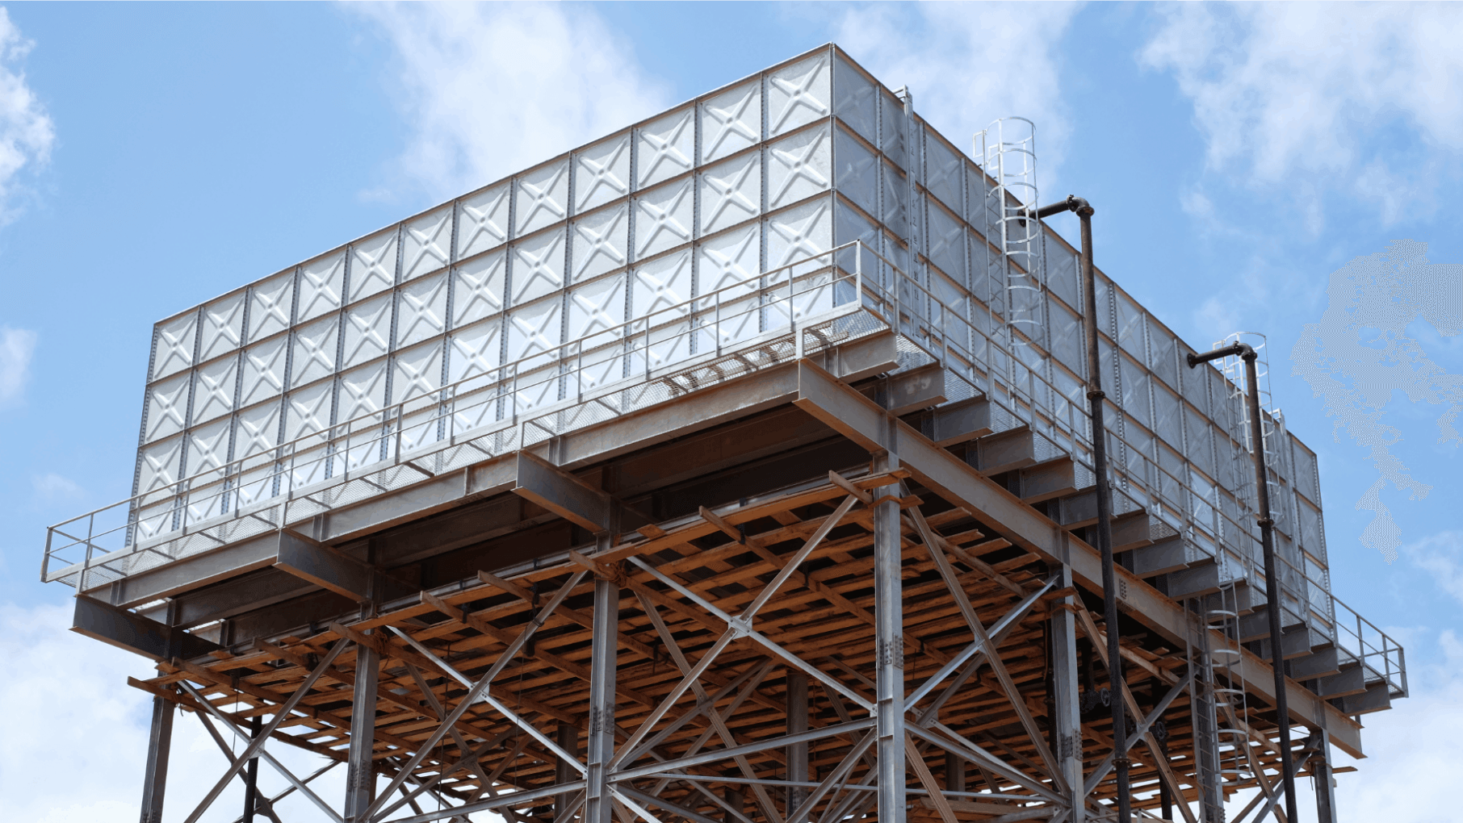
Tagline 1: Reliable Water storage for a sustainable future

Photo 2
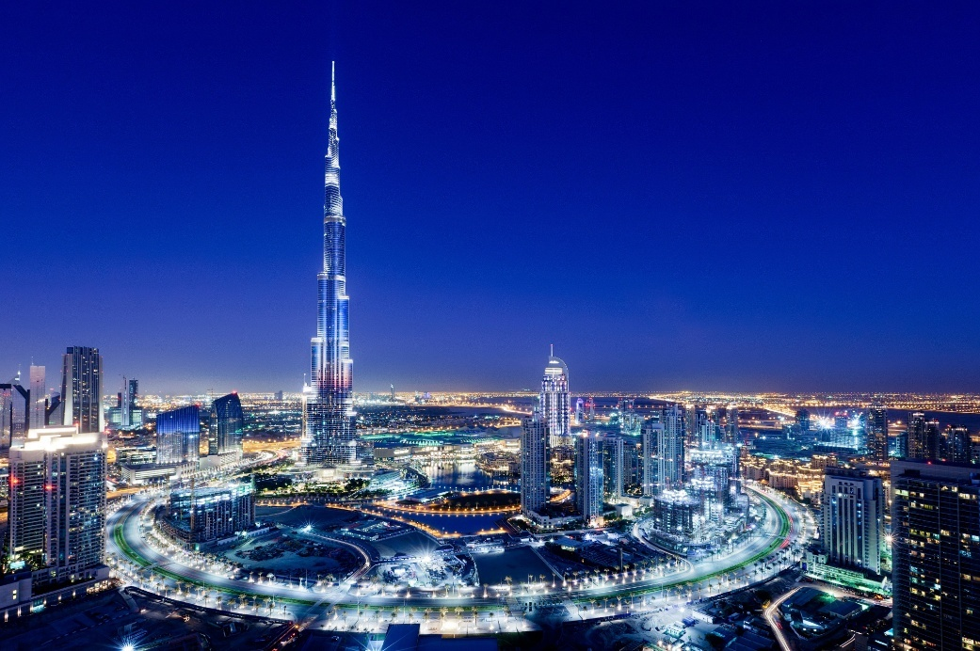
Tagline 2: Build confidently with SUNNIK - The World’s Most Certified Water Tank
Below Tagline 2 (Smaller font): Sunnik is the trusted partner for SS316 tanks and lining at multiple levels for the iconic Burj Khalifa

Buttons: Contact us (Should go to contact section at bottom)

Our Products

Pictures are in Photos file (Could you add 2 for each product like changing photos)
Please Adjust and crop photos to show product nicely
3 product Cards Clickable product cards - With Download catalogue button and click to open Pop-ups with detail

GRP Tanks
Glass Reinforced Polymer combining strength, durability, and light weight with 6X Safety Factor

HDG Steel Tanks
Hot-Dip Galvanized Steel offering exceptional strength and corrosion resistance

Stainless Steel Tanks
SS304, SS316 & SS444 Grade tanks - NSF61/ANSI certified for superior hygiene

Clicking each product card should pop-up with this detail in Each product category:
GRP Tanks –
SUNNIK GRP Panel Tanks

Glass Reinforced Polymer (GRP) combines strength, durability, and light weight, making it the material of choice in industries that demand reliability. Sunnik has perfected this technology to create GRP Sectional Panel Tanks that outperform traditional storage methods.
Key Features
- Hygienic, weather and disaster-resistant design suitable for High temperatures
- 6X Safety Factor for exceptional reliability
- Compliance with Global Quality Standards: BS EN 13280, SS245:2014, and WRAS BS6920:2014
- Superior insulation - thermal conductivity 240X lower than steel
- Optional 25mm or 50mm polyurethane foam for energy efficiency
- Lightweight yet extremely strong construction

HDG Steel Tanks -
SUNNIK HDG Steel Panel Tanks
Hot-Dip Galvanized (HDG) Steel is renowned for its exceptional strength, durability, and corrosion resistance, making it a trusted material for heavy-duty industrial and infrastructure applications. Sunnik leverages this proven technology to deliver HDG Steel Sectional Tanks that offer robust and reliable water storage solutions.
Key Features
- High-strength, long-lasting construction
- Exceptional corrosion resistance
- Adaptable to wide range of applications
- Resilient against mechanical stress
- Suitable for demanding site conditions
- Modular panel construction for flexibility

Stainless Steel Tanks-
SUNNIK Stainless Steel Panel Tanks (SS304, SS316, SS444)

Hygienic & Durable: Engineered for superior corrosion resistance and long-term performance, Sunnik Stainless Steel Tanks ensure safe, reliable storage for potable water and industrial applications. Stringent manufacturing using dedicated stainless-steel equipment ensures top-quality panels free from contamination by corrosion-prone metals.

Key Features
- NSF61/ANSI/CAN and FDA food-safe certified
- Fully compliant with AISI standards
- First in Malaysia with SPAN approval for municipal water use
- SS304, SS316, and SS444 grade options
- Contamination-free manufacturing process

Sunnik Product Certifications
SUNNIK’s global certifications and approvals reflect unmatched quality, safety, and international compliance.
Can use these files directly or will share photos File as well.
Order of certifications LOGOS: UL, NSF, LPCB, WRAS, TUV, Intertek, QAS SIRIM, Lloyd’s register, NCREE, UL Greenguard, Dubai Electricty and water authority
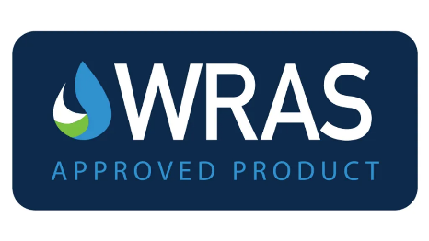
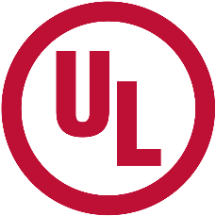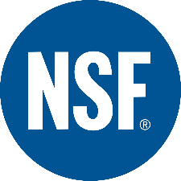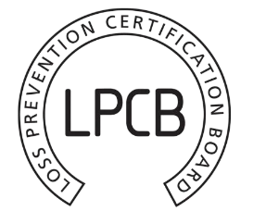
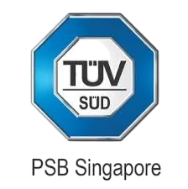
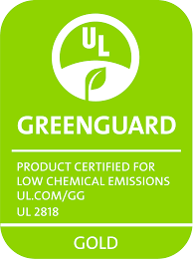
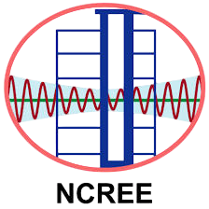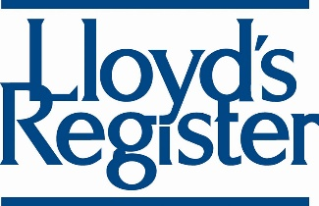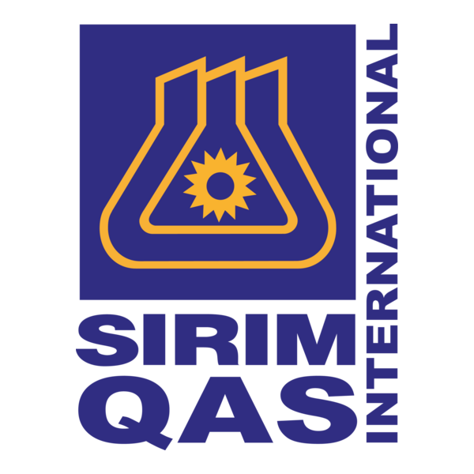

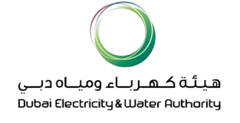

Sunnik’s Exceptional Track-record

Burj Khalifa, UAE
SS316 stainless steel water tanks for the world's tallest building

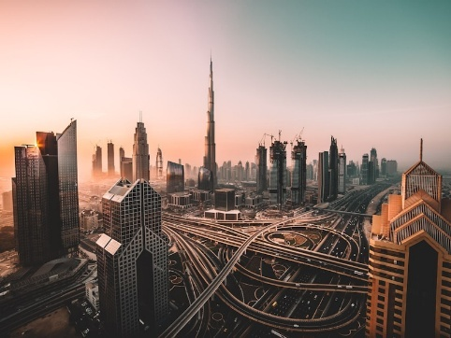

POP-UP Detail
Supplied & installed
SS316 Tanks installed at multiple levels highest installation at Level 160
8 units x 72m³ SS316L type
14 units x 1277m³ SS316L Lining for RC tanks

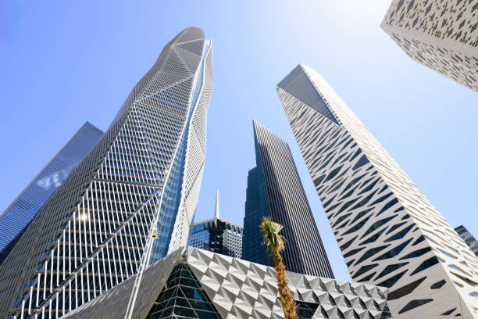
Tadawul Tower, KSA
SS444-grade tanks for Iconic Tadawul towers at KAFD
POP-UP Detail
Supplied & installed
1 unit x 180m³Stainless Steel 444 type
1 unit x 425m³ Stainless Steel 444 type
1 unit x 370m³ HDG type
1 unit x 304m³ HDG type
1 unit x 327m³ HDG type with HDPE Lining

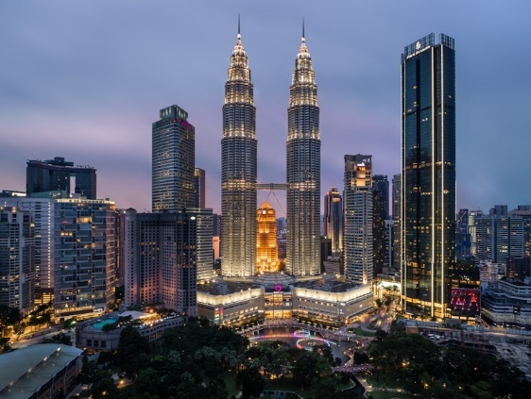

PETRONAS TWIN TOWERS, KUALA LUMPUR
Provided HDPE tank linings for the world’s tallest twin towers

POP-UP Detail

Supplied & installed
2 units x 854m³ HDPE Lining for RC tank
2 units x 592 m³ HDPE Lining for RC tank

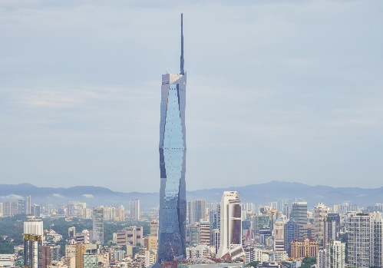
MERDEKA 118, KUALA LUMPUR
GRP and HDG tank project

POP-UP Detail

Supplied & installed
1 unit x 100m³FRP type
1 unit x 104 m³ FRP type
1 unit x 371 m³ HDG type with HDPE Lining
1 unit x 305 m³ HDG type with HDPE Lining
1 unit x 327 m³ HDG type with HDPE Lining

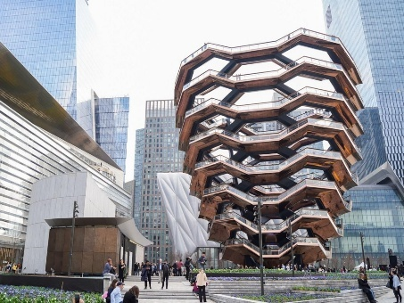
HUDSON YARDS, NEW YORK CITY
GRP tanks project

POP-UP Detail

Supplied & installed to date
1 unit x 108m³ SMC/FRP type
1 unit x 52.5m³SMC/FRP type
1 unit x 73.5m³ SMC/FRP type
1 unit x 6m³ SMC/FRP type
1 unit x 90.75m³ SMC/FRP type
1 unit x 81m³ SMC/FRP type
1 unit x 84m³SMC/FRP type
1 unit x 72m³SMC/FRP type
1 unit x 315m³ SMC/FRP type
1 unit x 175.5m³ SMC/FRP type

Sports City Tower, Doha
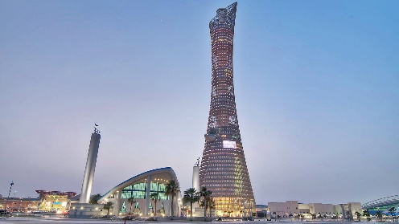
POP-UP Detail

Supplied & installed
2 units x 127m³ HDG type

About us
(Add pictures)

At Aspire Solutions, we are dedicated to delivering premium water storage solutions as the authorised distribution and installation partner of Sunnik Panel Tanks in the region. Our mission is to be Saudi Arabia’s most trusted name in the water storage solutions industry, supporting the Kingdom’s growth and development vision.
We are committed to delivering reliable Panel Tanks that are built to last and engineered to withstand the region’s demanding climate and environmental conditions. Through innovation and reliability, we aim to set new benchmarks for water storage excellence across the Kingdom.
We aim not only to meet but to exceed customer expectations with our service and delivery. Our ambition is to be the partner of choice for organisations seeking trusted, future-ready water storage solutions that create long-term value for our clients.

Sunnik - Our Manufacturing Partner
Global Leader in Water Storage Technology
Add Sunnik corporate video Box – From youtube

With a presence in over 42 countries worldwide and compliance with top-notch international standards and certifications such as NSF and WRAS, Sunnik has earned the trust of clients across diverse climates and industries—from the Middle East and Asia to Africa, Europe, and beyond ensuring reliability, safety, and durability.

Sunnik has delivered reliable water storage solutions for landmarks such as Burj Khalifa (UAE), Petronas Twin Towers (Malaysia), Tadawul Tower (Saudi Arabia), and Kuala Lumpur International Airport (KLIA I & II), reflecting its engineering excellence and project reliability.
Sunnik employs cutting-edge design and fabrication methods to ensure the quality and consistency of each panel, utilizing technologies such as robotic welding, laser cutting, and sheet molding compound (SMC) with 1,000-metric-ton hot-pressed compression. Sunnik actively seeks and adopts the latest innovations from leading manufacturers in Britain, Japan, and international joint ventures. Sunnik was the first in the region to introduce hydraulically pressed sectional steel tank covers designed for walking support, epoxy-coated sectional panel tanks, and stainless steel panel tanks in grades SS316 and SS444.
All Sunnik tank systems are earthquake-tested up to 1.5g. The company’s glassfiber-reinforced polymer (GRP) panel tanks comply with the British Standards Institute quality standard (BS EN 13280:2001) and are engineered with a factor of safety (FoS) six times greater than the maximum anticipated loads—whereas other brands typically use a safety factor of only four.

Contact Us
Email: Sales1@aspiresolutions-co.com,
Phone No: +966 54 793 9470, whatsapp chat link: +966 54 793 9470
Address: Dammam 36332, P.O. Box 35850
Kingdom of Saudi Arabia,
Contact form ( Filling this should Send mail to Sales1@aspiresolutions-co.com)
- Name
- Email
- Phone
- Subject
- Message
Below are just pictures for reference

Sunnik GRP tanks

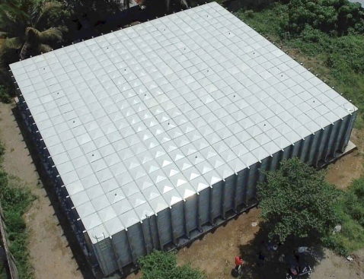
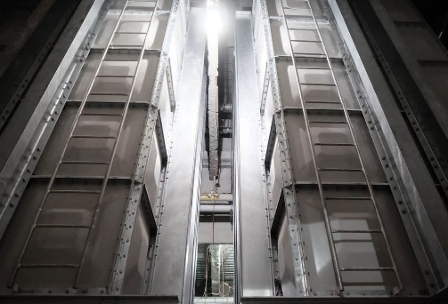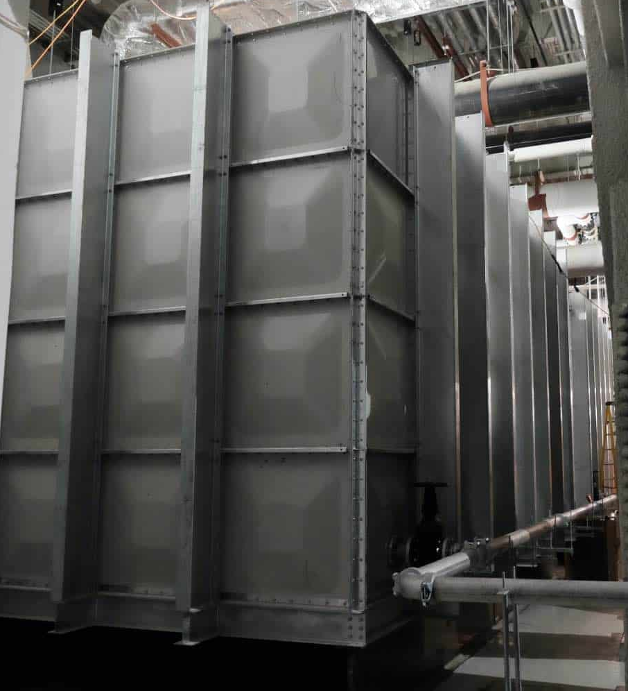

SUNNIK HDG Steel Tanks
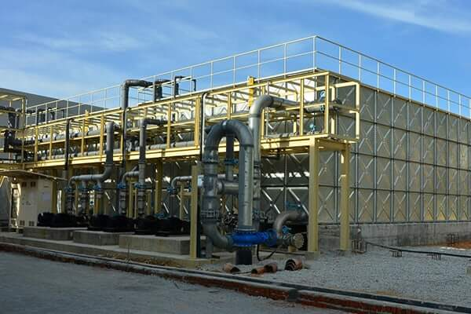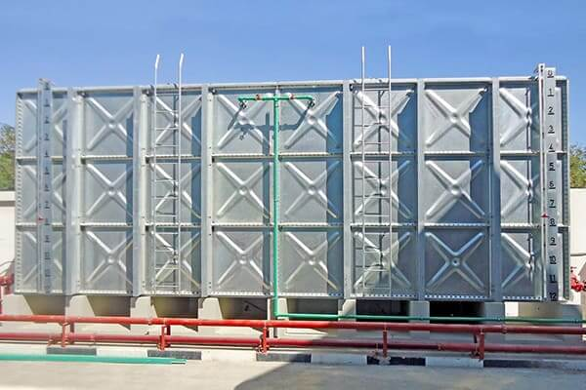

SUNNIK Stainless Steel Tanks (SS304, SS316, SS444)
